TONGA DOMESTIC

Created by Real-world Pilots for FSX Simmers

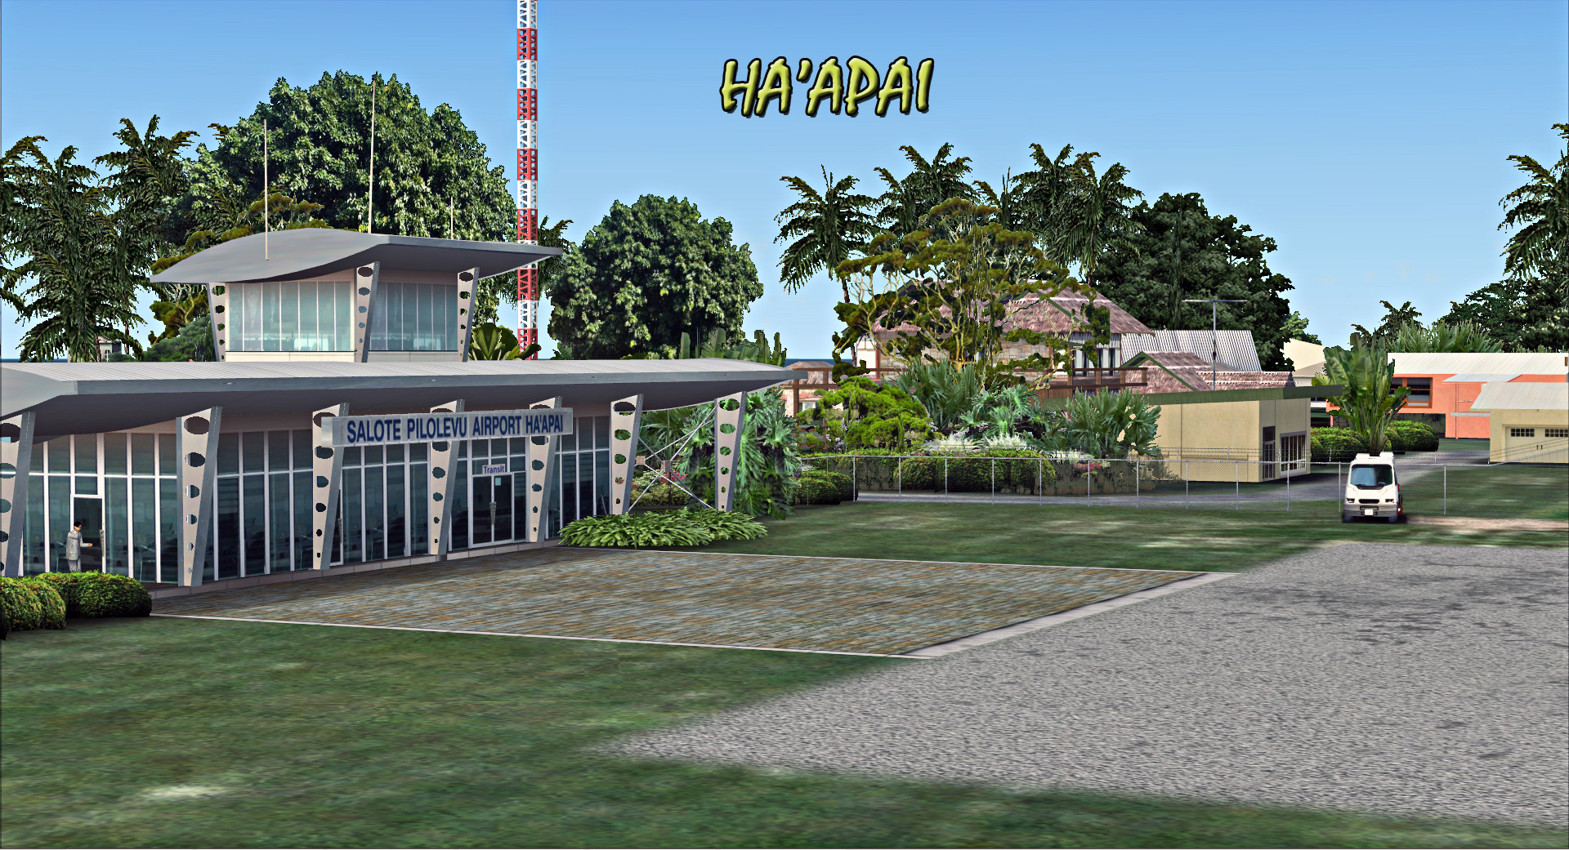

Graham Michael
Lead - Software Design & Development

Pacific Islands Simulation, LLC
Martinsburg, West Virginia USA

www.islandsim.com
www.islandsim.com/pis_forum
toksawe@gmail.com

© 2011 All Rights Reserved

: 1 :

A. GEO-POLITICAL BACKGROUND AND HISTORY
Situated east of the Fiji Islands in the South Pacific, Tonga (also called the Friendly Islands) consists of some 150 islands, of which 36 are inhabited. Most of the islands contain active volcanic craters; others are coral atolls.
Polynesians have lived on Tonga for at least 3,000 years. The Dutch were the first to explore the islands, landing on Tafahi in 1616. British explorer James Cook landed on islands in 1773 and 1777 and dubbed them the Friendly Islands. The current royal dynasty of Tonga was founded in 1831 by Taufa'ahau Tupou, who took the name George I. He consolidated the kingdom by conquest and in 1875 granted a constitution. In 1900, his great-grandson, George II, signed a treaty of friendship with Britain, and the country became a British protected state. The treaty was revised in 1959. Tonga became independent on June 4, 1970.
The government is largely controlled by the king, his nominees, and a small group of hereditary nobles. In the 1990s a movement began aimed at curtailing the powers of the monarchy, and the Tongan Pro-Democracy Movement (TPDM) has continued to gain in popular support. In 1999, Tonga gained UN membership.
The king grew increasingly authoritarian and has curtailed press freedom. In 2005, 3,000 civil servants went on strike, demanding better pay. Throughout 2005, discontent with economic and social inequities intensified throughout the kingdom. As a result, Prince 'Ulukalala Lavaka Ata resigned as prime minister in Feb. 2006. The following month pro-democracy leader Feleti Sevele became the first elected commoner to serve as the country's prime minister. In Aug. 2006, the king died and was replaced by his son, George Tupou V.
Read more here: Tonga: History, Geography, Government, and Culture — Infoplease.com http://www.infoplease.com/ipa/A0108042.html#ixzz1QUP5IwAW

B. AIRPORT BACKGROUND

The three Tonga domestic airport caters for small to medium type aircraft ferrying local passengers and freight between local Tongan islands and neigbouring Fiji, Samoa, Niue and Cook Islands. Chatham Pacific and Peau-Vava'u are the only two active domestic airlines operating the islands.

: 2 :

1. HA'APAI-LIFUKA AIRPORT (ICAO: NFTL)

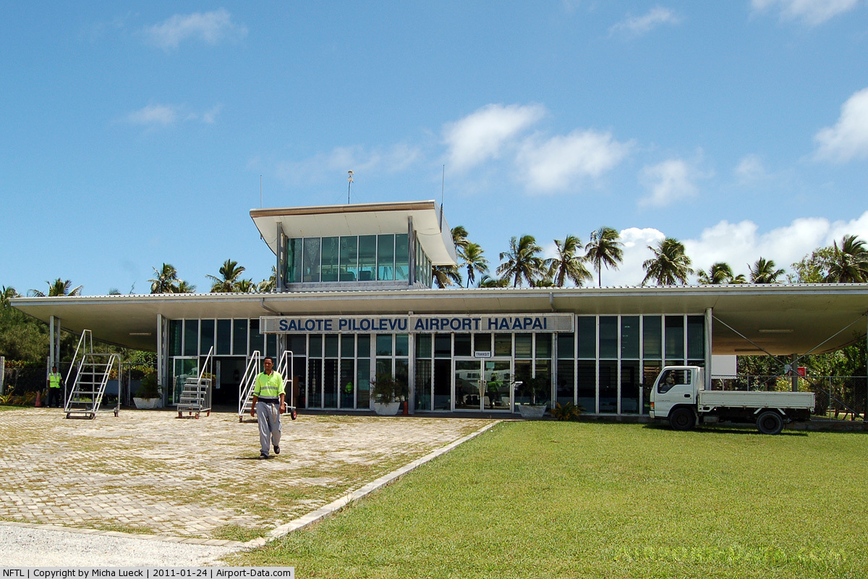

Also known as Salote Pilolevu Airport, it is situated due north of Fua'amotu International (NFTF). It is 99nm from Fua'amotu and 75nm due south of Vava'u International (NFTV).

Airport Facilities and Reference

RWY 10/28 H3,937x98ft/1200x30m (bituminous, tar or asphalt mixed in place, oiled)

Airport Elv. 126ft/38m

Twr Ops: None.

Navaid. HA – NDB 380.0 75.02nm range

Communication. Lifuka FSS. 118.10
ARTCC. Oakland/Auckland/Nadi

Airport Remarks/NOTAM
- Constant crosswind daylight hrs
- Rwy 10/28 has REIL and Strobes for night ops.
______________________________________________________________________________

: 3 :

2. VAVA'U INTERNATIONAL AIRPORT (ICAO: NFTV)

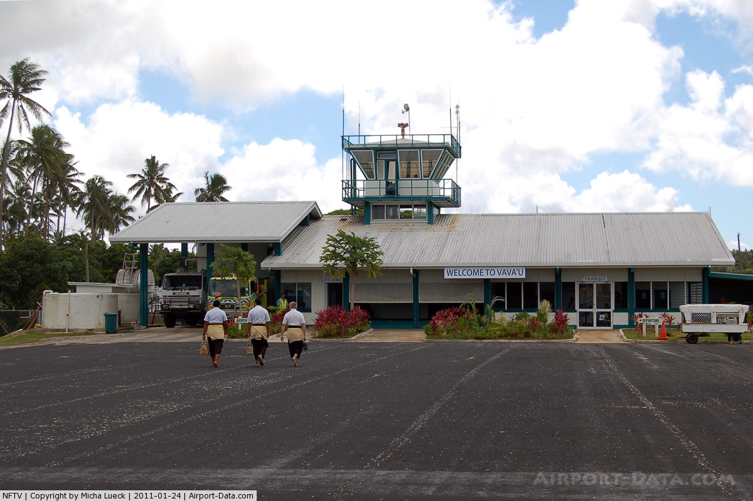

Also known as Lupepau'u International Airport, it is located 75nm north of Ha'apai-Lifuka (NFTL) and 173nm from Fua'amotu International Airport (NFTF).
Vava’u is Tonga’s main tourism hub, where some 34 islands provide both dramatic scenery and a world renown center for water related activities; sailing, fishing, diving. In season (July-October) humpback whales migrate north to mate and calf in the warm waters of Vava’u providing spectacular sights for visitors as well as opportunities to swim with whales.
The airport is located 10 km (6.2 mi) north of the capital Neiafu.
Vava'u is an international airport however scheduled international flights no longer operate with all such flights arriving in Tongatapu. Charters and private aircraft still use the International facilities at Vava'u. Domestic air services are operated by Chathams Pacific Airlines which is a wholly owned subsidiary of New Zealand Airline Air Chathams Ltd. Chathams Pacific offers twice daily flights to and from Tongatapu. They generally run a 50 seat Convair 580 on this route with an 18 seat Metroliner also used periodically.

: 4 :
Less frequent services connect Vava’u to Ha’apai, Niuafo’ou and Niuatoputapu. Flight time is 50 minutes to Tongatapu, 30 minutes to Ha’apai and a little over one hour to both Niuatoputapu and Niuafo’u.
(Source: http://en.wikipedia.org/wiki/Vava'u_International_Airport)

Airport Facilities and Reference

RWY 08/26 H5,593x98ft/1659x30m (Asphalt-Bituminous mixed in place, oiled)

Airport Elv. 236ft/71.9m

Twr Ops: None daily, but manned on special occasions only

Navaid. TV – NDB 400.0 75.02nm range

Communication. Vava'u Multi comm. 118.10 and 118.50
ARTCC. Oakland/Auckland/Nadi

Airport Remarks/NOTAM
- Constant crosswind daylight hrs
- Low level fogs morning and evenings
- Rwy 08/26 has REIL, ODALS and Strobes for night and foggy ops.
- Terrain and other obstacles on approach at both rwy ends. Observe PAPI 4 and rwy marker displacements.
______________________________________________________________________________

3. NIUATOPUTAPU (ICAO: NFTP)
Niuatoputapu is one of the two Niuas (Niuafo’ou, being the other) situated farthest north of all the islands of Tonga. It is halfway between Vava’u and Samoa. By plane, it is 157nm from Vava'u, 230nm from Ha'apai-Lifuka, and 325nm from Fua'amotu International Airport. Niuatoputapu by location is remote and undeveloped, while Tongan tradition culture remain strong. The climate is noticeably warmer than the southern parts of the Kingdom. Niuatoputapu is a flat coral island but there is a 200 metre high ridge running along the central part of the island, with volcanic Tafahi Island just offshore. Beautiful beaches and small traditional communities with elaborate churches surround the island.
Limited domestic air services operated by Chathams Pacific connect Niuatoputapu to Vava’u and Tongatapu. The airfield is an unsealed coral strip.
(Source: http://www.tongaairports.com/airports/niuatoputapu-airport/)

: 5 :

Airport Facilities and Reference

RWY 11/29 H4,265x88ft/1300x27m (coral with grass)

Airport Elv. 17ft/5m

Twr Ops: None

Navaid. None

Communication. Vava'u Multi comm. 118.10 and 118.50
ARTCC. Oakland/Auckland/Nadi

Airport Remarks/NOTAM
- Constant crosswind daylight hrs
- Low level fogs morning and evenings
- Rwy 11/29 has REIL and Strobes for night and foggy ops.

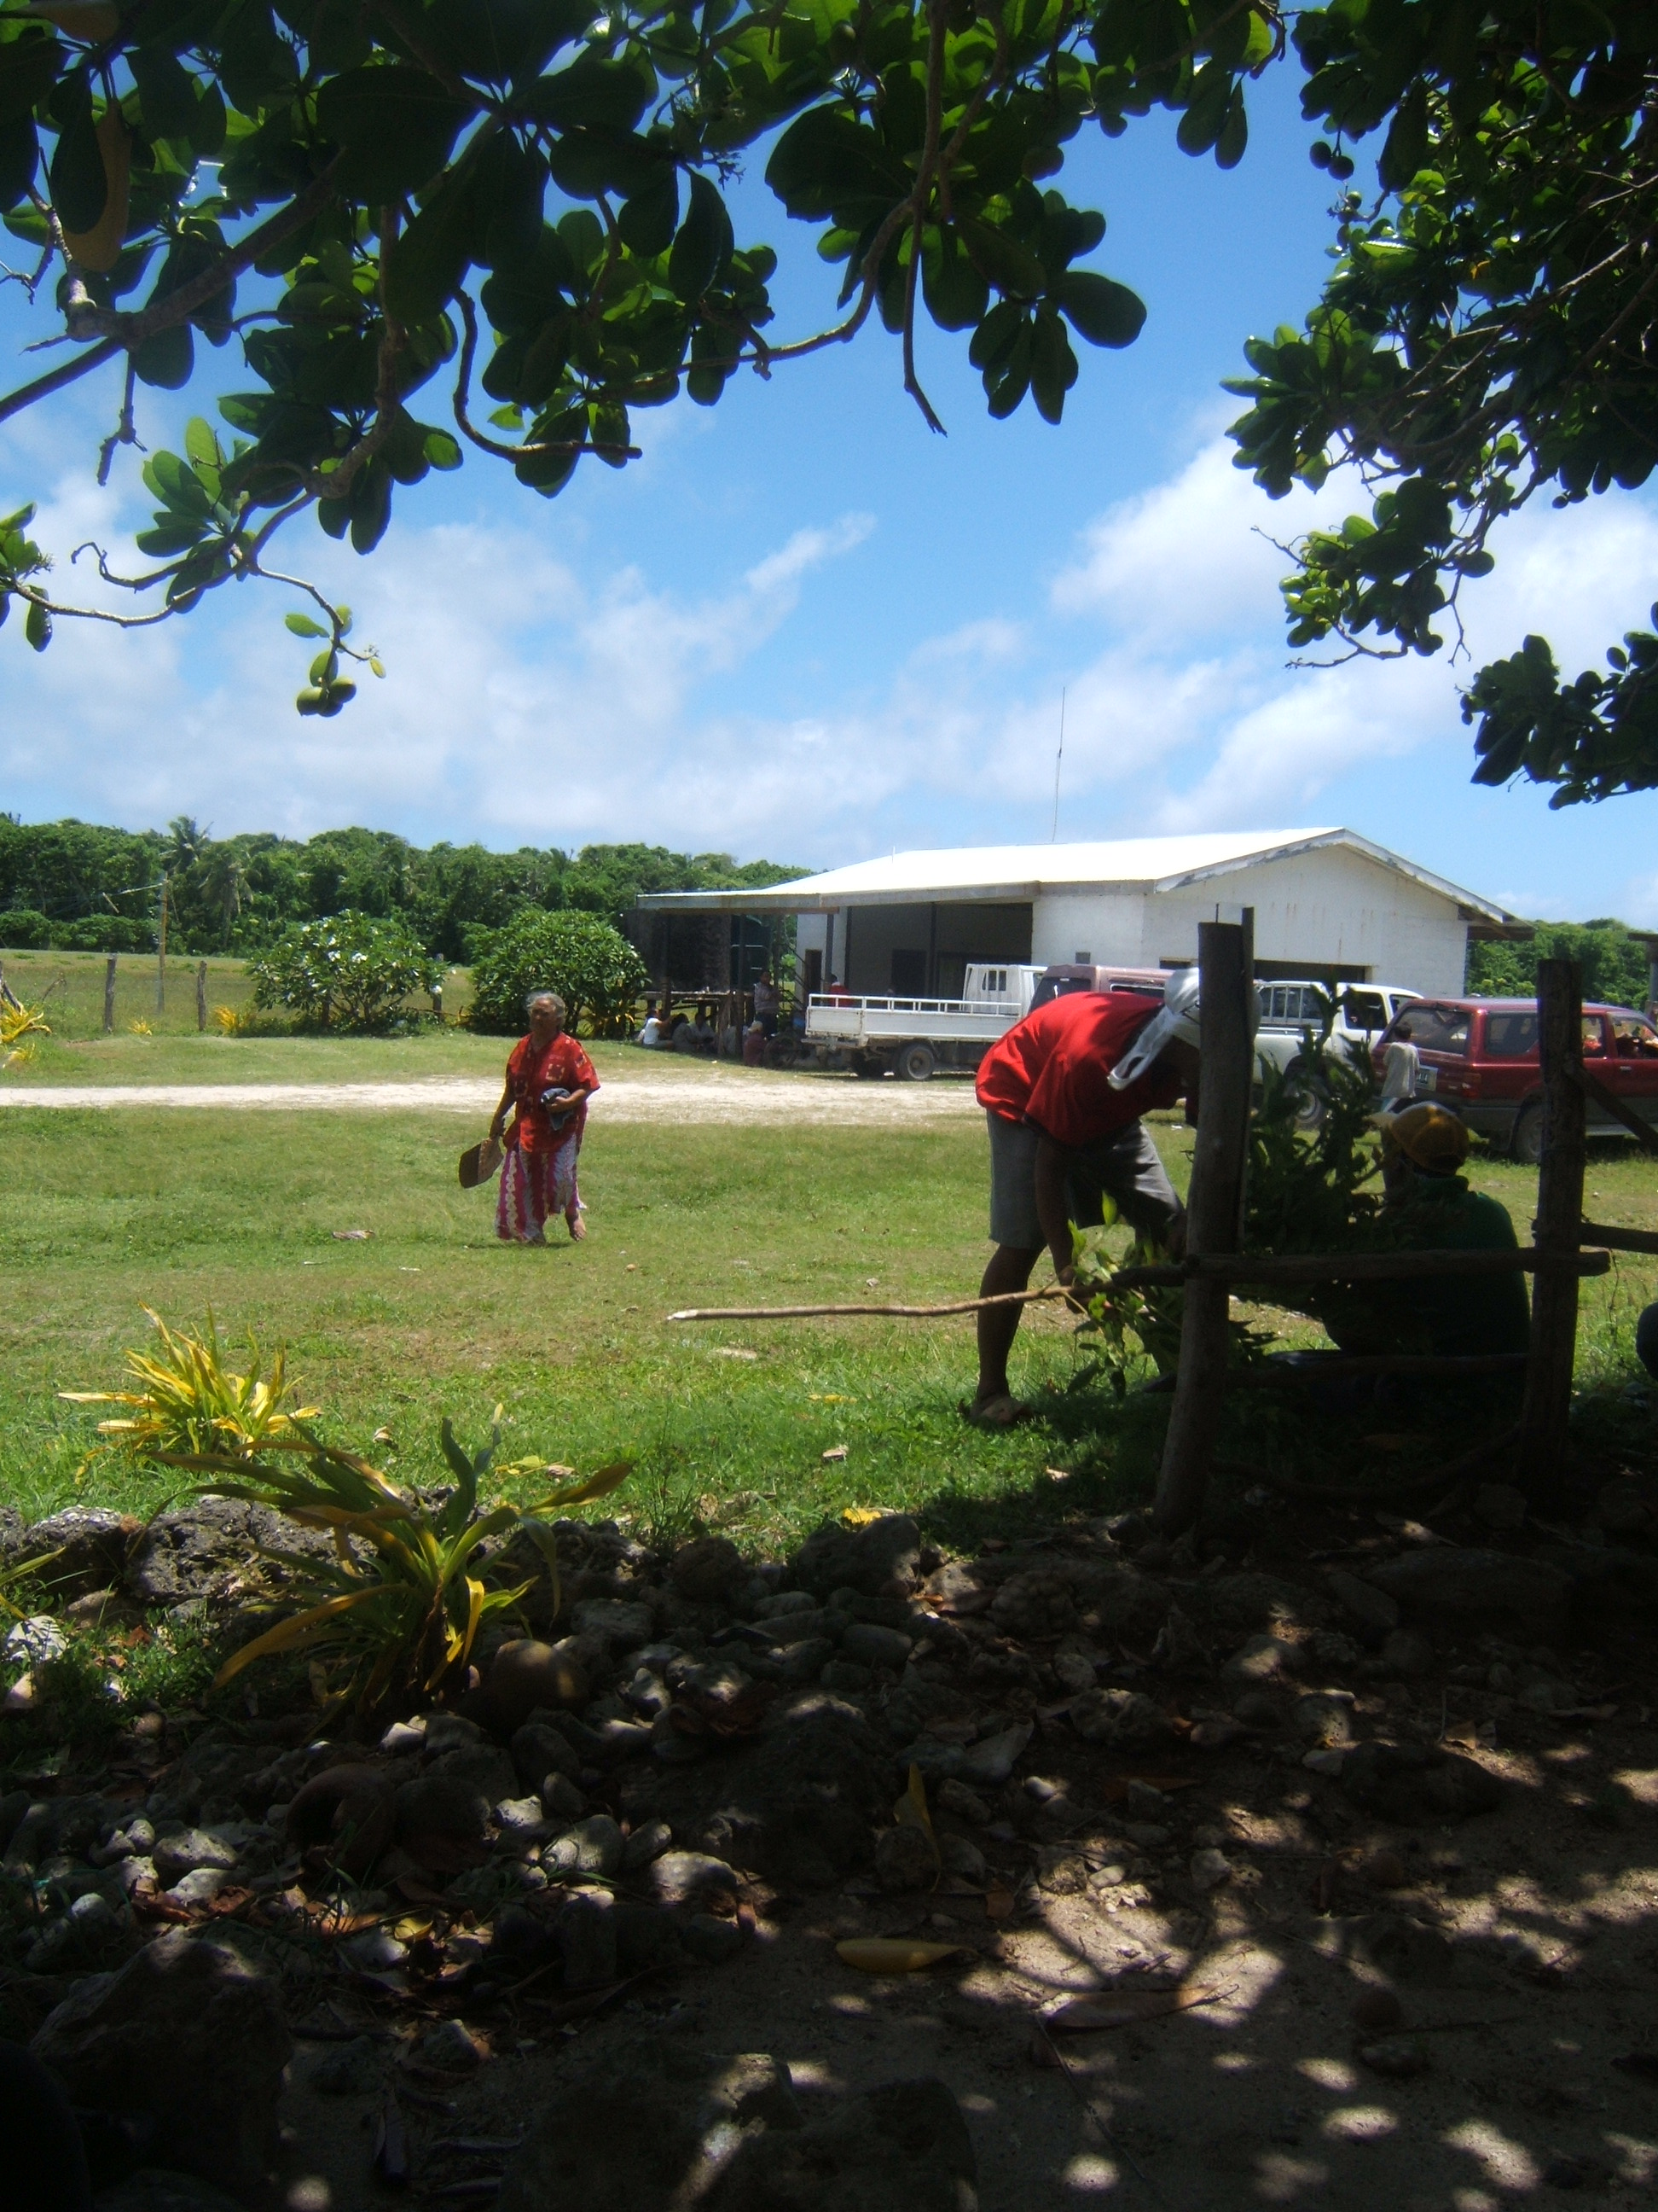

______________________________________________________________________________

: 6 :

E. PRODUCT FEATURES

- Accurate terminal buildings;
- Photoreal coverage of all three islands
- Custom runway and ground/apron textured polygons;
- Custom vegetation and objects;
- 3D grass
- Upgraded terrain mesh for the airport area;
- Complete hand-textured coloration of land and waterclass;
- Night lighting and effects;
- 15/30/60cm/pixel photoreal texture;
- Framerate-friendly (including full autogen enhancements for framerate fluidity using SDK annotator). This means all sliders to the right with very minimal fps impact;
- Runway and apron/tarmac markings;
- MyTrafficX compatible for real-world schedules and airline liveries that frequent the Tongan islands;
- 76m or higher resolution terrain mesh compatible.
- ....and more.

F. SYSTEM-SPECIFIC REQUIREMENTS

Tonga Domestic was developed on a medium system for medium to high-end computers, and was tested on WinXP, Vista and Win7 32/64 bit platforms with medium to high-end graphic cards. Specific requirements include:

- Microsoft Flight Simulator X (SP1, SP2/Acceleration)
- Pentium IV 2.6 GHz (2GHz Duo2Core Intel and above or equivalent advised)
- 1 GB RAM and above recommened
- 256 Mb DirectX 9/10 graphics card (512 Mb or higher recommended)
- Word for Windows (Microsoft Office) or Adobe Acrobat® Reader 6 minimal to read and print the manual.
- Over 700mb of hard disk space

G. RECOMMENDED FSX SETTINGS
Frame rates from scenery complexity and autogen settings were averaged at 30fps and above. This includes moving sliders 100% to the right. Lower settings yielded much higher frames, but our recommendation is Dense to Extreme Dense for variable exceptional rates. Since the scenery is 15/30/60cm/pixel photoreal, it is highly recommended that Mesh Resolution be set at 1 meter within FSX Display Settings (slider 100% to the right). Texture Resolution should also be set at 30cm and above (or slider 100% to the right).
Mesh Requirement:
To enjoy the product's terrain conditions comparative to real-world, we recommend using any 76m or higher resolution mesh from any of these vendors: FS Genesis, Abacus's "World and USA Extreme Landscapes," or FSGlobal.
: 7 :
If you can't afford these products, you can still get the same mesh resolution from Thomas Trewin's Oceania-Asia series. The five-part terrain mesh can be downloaded here:
http://simviation.com/1/search?submit=1&keywords=SRTM%2BWest%2BAsia&categoryId=&page=1&filename=

Recommended AI Traffic requirements and settings:

There are AI boat traffic around all three islands. To maintain a formidable exceptional level of FPS, it is recommended that leisure boats be set at 30% or less. AI road traffic is only found at/near the airport so as to save on FPS. Recommended setting is 10% or lower.

MyTrafficX is our choice of commercial AI air traffic engine especially to reflect compatibility with real-world schedules and airline liveries that frequent Fua'amotu. So you need that to experience and see AI traffic flow.

H. PRODUCT DISCLOSURE and DISCLAIMER

Similar to any Flight Simulator (FS) Addons, this product may have issues that are either default (Microsoft-related) or developer-related. Issues that are MS-related, whether documented or undocumented are many, but we can only speak for our product. Although there are no micro-stutters or huge lag in fps as tested, it is advisable to lower the Water Effects within FSX Display Settings to High 2x. and set Autogen down to respectable levels for fluidity. These are recommended for lower to medium-end systems, however the scenery is meant for sliders maxed at 100% peak for those computers who can afford the high level scenery design.

No technical issues were encountered during various beta tests, whether hardware or software- related. Instructions for installation of software are straightforward; however, venturing outside bounds of recommended installation and use is at sole discretion of End-User.

We will not bear responsibility for issues resulting from installation of the product, in part or full, into former Flight Simulator platforms which includes FS2004 because the product is not backward compatible. Furthermore, we will not be held responsible if files are altered within software for any reason associated with End-User taste or choice.

The product is Non-refundable for these and various other reasons.

: 8 :

I. ACKNOWLEDGEMENT

As usual, we are deeply grateful to those who contributed to development of this product. The list includes:

1, Tom Vele - for providing background information, photos, and details of all the islands.
2. Henry Pearce - for landclass and waterclass textures
3. Syed Shibli - for testing product
4. Capt. Steve Austin - formerly of Polynesian Airlines for testing product
5. Manase Hudson - for testing product
6. Pete Bretler - for testing product
7. Ken (Timber) Alger - for testing product.

…and to those I may have inadvertently left out in this Acknowledgement, we highly value your contribution as well.

Graham Michael
Lead - Software Design & Development

